RESEARCH PAPER

Customer Segmentation & Churn Pattern Analytics in European Banking

A Segmentation-Driven Exploratory Data Analysis

Dataset: European Bank Customer Dataset | N = 10,000
Geographies Covered: France • Germany • Spain

In Association with Unified Mentor Pvt Ltd,
Under the Guidance of Mr. Saiprasad Kagne

Completed by Piyush Pant
Date: May 2026

Analytical Domain: Retail Banking • Customer Intelligence • Churn Analytics

Abstract
Customer churn is one of the most significant drivers of revenue erosion in European retail banking. Despite rich transactional and demographic data, most banks lack the granular segmentation intelligence needed to design targeted, data-driven retention strategies. This paper presents a comprehensive Exploratory Data Analysis (EDA) of a European banking dataset comprising 10,000 customers across France, Germany, and Spain. Through a systematic multi-dimensional segmentation framework spanning geography, age, credit score, tenure, account balance, gender, and financial stability, this study identifies the precise customer cohorts most susceptible to churn.

Key findings reveal an overall churn rate of approximately 20.4%. Germany exhibits the highest regional churn rate at 32.4%, over twice that of France (16.2%) and Spain (16.7%). Age-based analysis shows that the 30–45 cohort contributes 65.9% of total churn. Gender analysis confirms female customers churn at a notably higher rate (~25.1%) than male customers (~16.5%). A composite High-Value Customer (HVC) scoring model reveals that Premium segment customers exhibit a 54.3% churn rate — the single largest revenue risk identified. Long-term customers (tenure > 7 years) paradoxically account for 61.4% of all churn.

Keywords: Customer Churn, Bank Customer Segmentation, European Banking, Exploratory Data Analysis, High-Value Customer Risk, Retention Strategy, Geographic Churn Analysis

1. Introduction

1.1 Background
Customer churn — the voluntary termination of a customer’s relationship with a financial institution — represents one of the most economically significant challenges in retail banking. The acquisition cost of a new bank customer is five to seven times higher than the cost of retaining an existing one. European retail banking operates in a uniquely competitive environment shaped by regulatory frameworks (PSD2, GDPR), fintech disruption, and a financially sophisticated customer base across France, Germany, and Spain.

1.2 Problem Statement
Despite accumulating extensive customer-level data, banks commonly resort to aggregate churn tracking rather than granular segmentation analysis, resulting in reactive, generic retention programmes. The critical analytical gaps are:
- Which customer segments exhibit the highest churn probability?
- How does churn behaviour vary across European geographies?
- Do high-value customers churn at disproportionate rates, and what is the associated revenue risk?
- What financial and engagement characteristics differentiate churned from retained customers?

1.3 Objectives
- Measure and contextualise the overall churn rate.
- Perform multi-dimensional segmentation and quantify segment-level churn rates.
- Conduct comparative demographic analysis across geography, age, gender, and financial profile.
- Identify high-value customer churn risk using a composite scoring model.
- Derive actionable strategic recommendations for bank retention management.

2. Literature Review & Theoretical Framework
The academic and industry literature on bank customer churn converges around several well-established themes. Customer lifetime value (CLV) models, first formalised by Reichheld and Sasser (1990), demonstrated that a 5% increase in customer retention can produce a 25–95% increase in profits. Subsequent research in European banking (Van den Poel & Lariviere, 2004) established that churn propensity is strongly correlated with product depth, engagement frequency, and relationship tenure.

Geographic and cultural dimensions of churn in European banking have received growing scholarly attention. Research consistently identifies Germany as a higher-churn market relative to France and Spain, attributable to a historically fragmented banking landscape and stronger consumer willingness to switch providers. Gender-differentiated churn behaviour has been documented in behavioural finance literature, with female customers showing higher switching rates in response to perceived service quality mismatches.

The concept of a Financial Stability Score (FSS) as a composite predictor of churn risk builds on the multi-criteria decision analysis (MCDA) framework applied to banking by Malhotra & Malhotra (2002). This study situates itself within the EDA tradition — leveraging visual and statistical decomposition of customer behaviour data — with predictive modelling forming the logical next research phase.

3. Data Description & Methodology

3.1 Dataset Overview
The analysis is conducted on the European Bank Customer Dataset containing 10,000 customer records spanning three European countries.

Column | Type | Description
CustomerId | Integer | Unique customer identifier
CreditScore | Integer | Credit score (350–850)
Geography | Categorical | France, Spain, Germany
Gender | Categorical | Male / Female
Age | Integer | Customer age in years
Tenure | Integer | Years as customer (0–10)
Balance | Float | Account balance (EUR)
NumOfProducts | Integer | Number of bank products held
HasCrCard | Binary | Credit card ownership (1=Yes)
IsActiveMember | Binary | Active engagement (1=Yes)
EstimatedSalary | Float | Annual salary estimate (EUR)
Exited | Binary | Churn label: 1=Churned, 0=Retained

Table 1: Dataset Schema and Variable Descriptions

3.2 Analytical Methodology
Phase 1 — Ingestion & Validation: Schema integrity, binary variable consistency, and churn label validation.
Phase 2 — Cleaning & Preparation: Removal of non-analytical identifiers, categorical encoding, and derivation of segmentation fields.
Phase 3 — Customer Segmentation: Multi-dimensional segmentation across Geography, Age, Credit Score, Tenure, and Balance.
Phase 4 — Churn Distribution Analysis: Segment-wise churn rates computed and visualised; churned vs retained profiles compared.
Phase 5 — Comparative & HVC Analysis: Gender and geography–age interaction analysis; FSS and HVC composite scoring; revenue risk quantification.

3.3 Derived Composite Features
Financial Stability Score (FSS): Weighted composite: Credit Score (30%), Balance (25%), Estimated Salary (20%), Tenure (15%), Products (5%), Active Member (3%), Credit Card (2%). Scaled 0–100; four tiers: At Risk, Moderate, Stable, High Stability.

HVC Score: Banking-domain composite: Balance Tier (35%), Multi-product / Deep Relationship (25%), Profitable Active (20%), Credit Worthiness (12%), Loyalty/Tenure (8%). Mapped to Standard, Silver, Gold, Private Banking.

Customer Value Score (CVS): Z-score normalised weighted composite emphasising Balance (30%), Products (20%), Credit Score (20%), with Activity, Tenure, Salary, Credit Card. Normalised 0–100; Low / Medium / High / Premium tiers.

4. Findings & Analysis

4.1 Overall Churn Rate
The dataset reveals an overall churn rate of 20.4% — 2,037 customers exited while 7,963 were retained. This is above the European banking industry benchmark of 10–15%, signalling structural retention challenges.

Status | Count | Percentage
Retained (Exited = 0) | 7,963 | 79.6%
Churned (Exited = 1) | 2,037 | 20.4%
Total | 10,000 | 100%

Table 2: Overall Churn Distribution

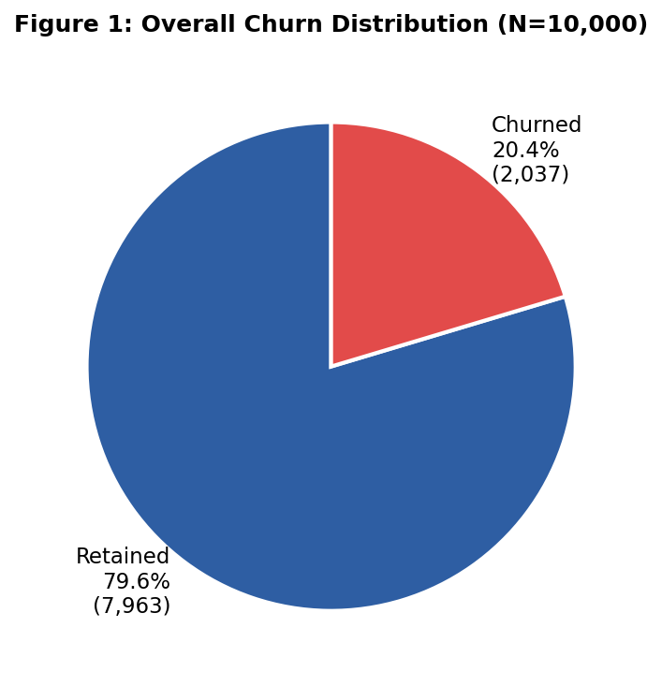
Figure 1: Overall Churn Distribution — Retained vs Churned

4.2 Geographic Segmentation & Churn
Geographic segmentation reveals stark differential churn rates across the three markets.

Geography | Total | Churned | Retained | Churn Rate
France | 5,014 | 810 | 4,204 | 16.2%
Spain | 2,477 | 413 | 2,064 | 16.7%
Germany | 2,473 | 814 | 1,659 | 32.4%
Total | ~10,000 | 2,037 | 7,963 | ~20.4%

Table 3: Geographic Churn Distribution

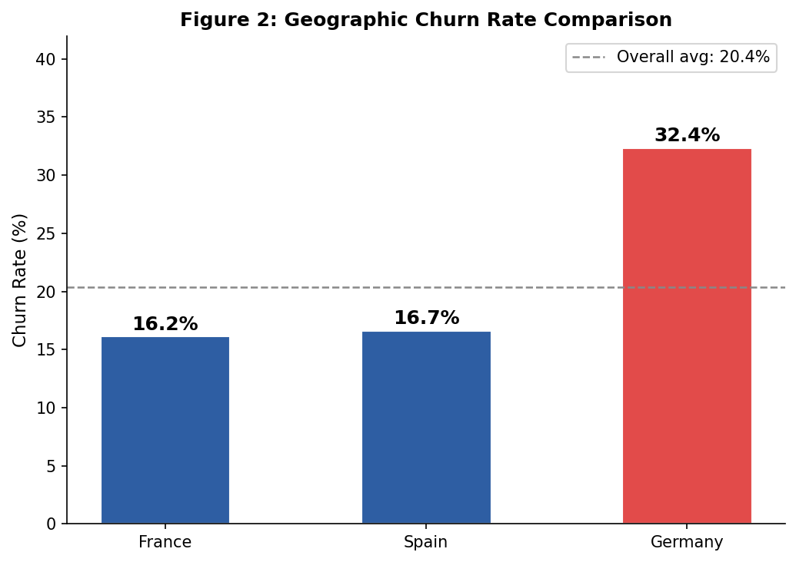
Figure 2: Geographic Churn Rate — Germany at 32.4% vs France/Spain ~16–17%

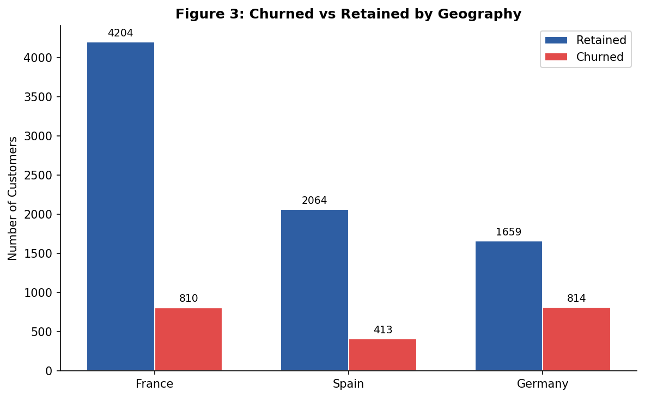
Figure 3: Churned vs Retained Absolute Count by Geography

Germany’s 32.4% churn rate is nearly double that of France and Spain. Despite having fewer than half the customers of France, Germany contributes 40% of all churned customers. In absolute terms, France leads churn volume (53.0% of all churned) due to population dominance, but on a rate-normalised basis Germany is the highest-risk geography by a significant margin.

4.3 Age Segmentation & Churn
Age is one of the most powerful predictors of churn in this dataset.

Age Band | % of Total Churn | Churn Volume (est.) | Risk Level
Under 30 | 20.6% | ~420 | Moderate
30–45 | 65.9% | ~1,342 | Critical
46–60 | ~9.8% | ~200 | High
Above 60 | ~3.7% | ~75 | Low volume

Table 4: Age Segment Churn Distribution

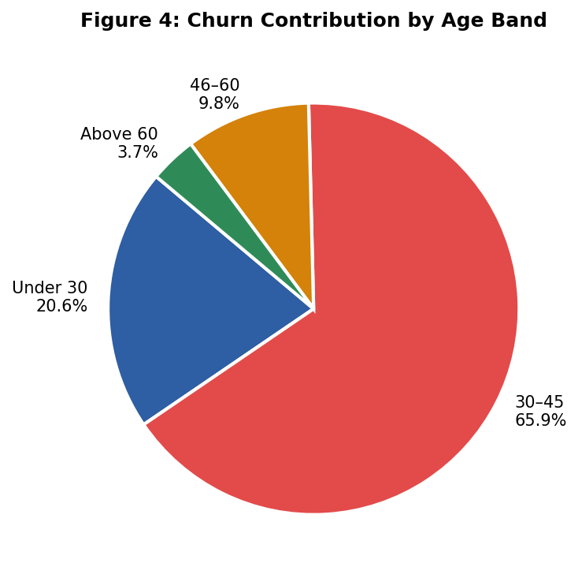
Figure 4: Churn Contribution by Age Band — 30–45 accounts for 65.9% of all churn

Over 85% of churn originates from just two age brackets. The 30–45 cohort — the bank’s largest customer segment — contributes 65.9% of churn. This group is in its peak financial decision-making phase and most responsive to competitive switching incentives. The under-30 segment contributes 20.6%, consistent with digitally-native, low-friction switching behaviour.

4.4 Credit Score Segmentation
Three credit score bands were constructed from quartile analysis: Low (350–583), Medium (584–717), and High (718–850).

Credit Score Band | Band Range | Churned (est.) | % of Churn
Low | 350–583 | ~408 | 20.0%
Medium | 584–717 | ~1,028 | 50.5%
High | 718–850 | ~601 | 29.5%

Table 5: Credit Score Band Churn Distribution

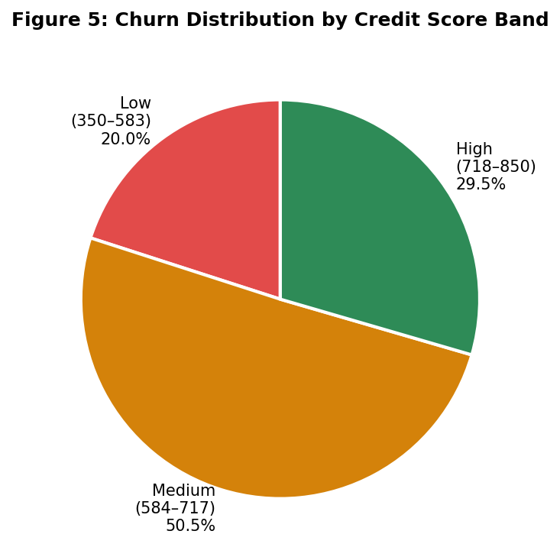
Figure 5: Churn Distribution by Credit Score Band — Medium score leads at 50.5%

Medium credit score customers account for 50.5% of churn due to population dominance. The Low band shows a disproportionately high rate relative to size, consistent with financial distress-driven disengagement. High-score churners (29.5%) represent credit-worthy, financially capable customers — their departure likely reflects competitive offer switching, a more strategically addressable problem.

4.5 Tenure Segmentation
Tenure was segmented: New (0–3 years), Mid-Term (4–7 years), Long-Term (8–10 years).

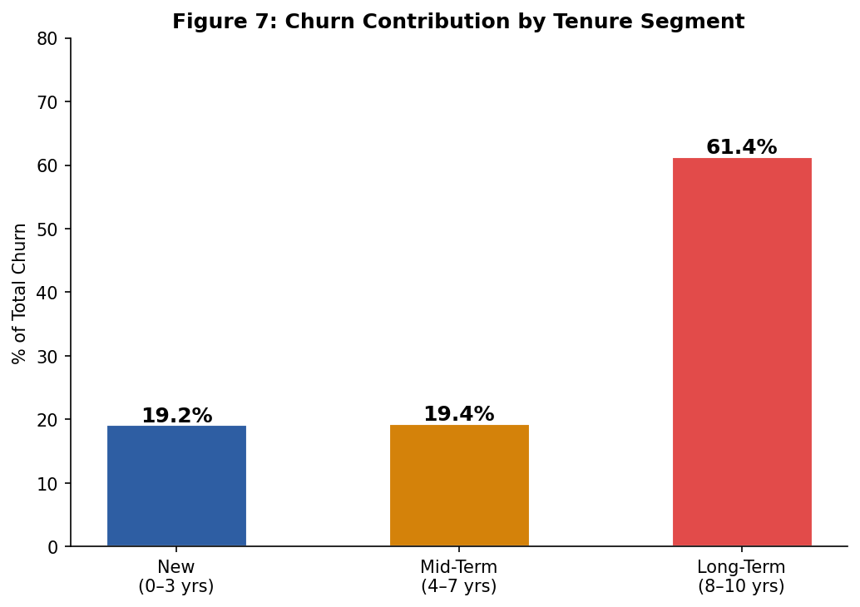
Figure 7: Churn Contribution by Tenure Segment — The Tenure Paradox: Long-term leads at 61.4%

A counterintuitive and strategically critical finding: long-term customers (tenure > 7 years) account for 61.4% of total churn. This contradicts the conventional assumption that tenure implies loyalty. Long-standing customers whose needs have not evolved with the bank’s product offering are vulnerable to eventual departure — often triggered by a single negative service experience or a competitive offer. Retention programmes must proactively target long-tenure customers, not passively assume their loyalty.

4.6 Balance Segmentation
Account balance was segmented into: Zero Balance (€0), Medium Balance (€1–€127,644), and High Balance (>€127,644).

Balance Segment | % of Churn | Key Insight
Zero Balance | 39.1% | Disengaged customers; exit before account closure
Medium Balance | 36.9% | Core mass-market churn risk
High Balance | 24.0% | Premium loss — highest revenue impact per churner

Table 6: Balance Segment Churn Distribution

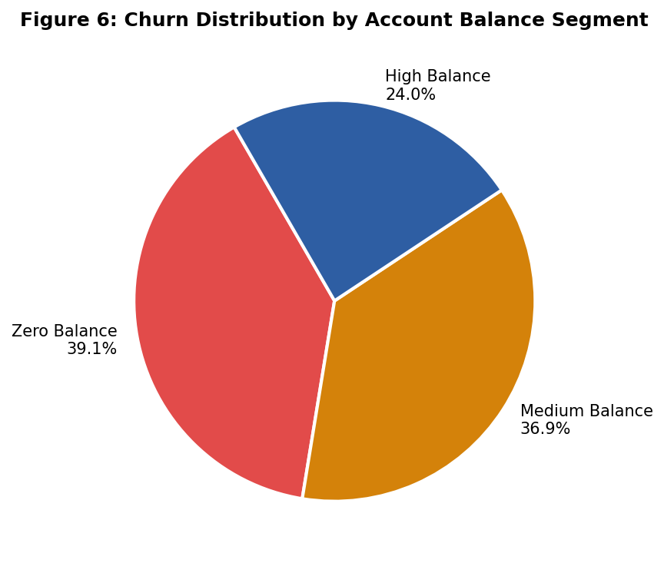
Figure 6: Churn Distribution by Account Balance Segment

Zero-balance customers lead churn contribution at 39.1%, indicating institutional disengagement over time. Medium-balance customers represent the largest mass-market risk. High-balance churners (24%) carry the greatest individual revenue impact per customer lost, warranting priority retention attention.

4.7 Gender-Based Churn Analysis

Gender | Total Customers | Churned | Churn Rate
Male | ~5,457 | ~898 | ~16.5%
Female | ~4,543 | ~1,139 | ~25.1%

Table 7: Gender-Based Churn Summary

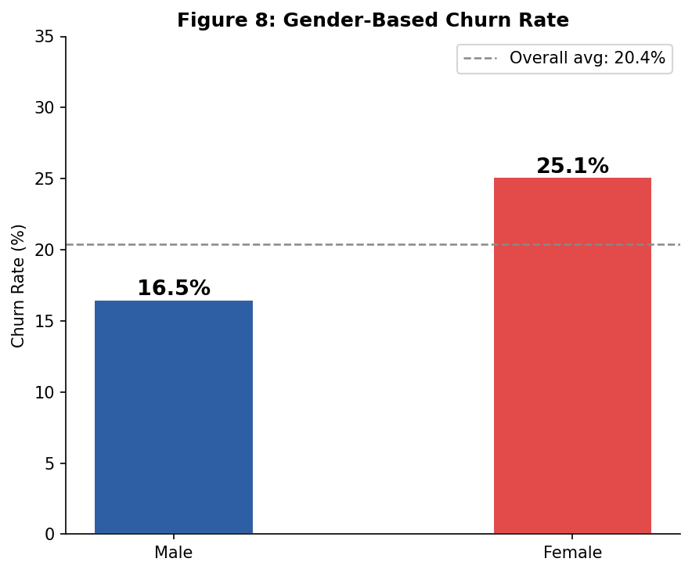
Figure 8: Gender-Based Churn Rate — Female customers churn ~8.6 pp higher than males

Female customers churn at ~25.1% versus ~16.5% for male customers — a gap of nearly 9 percentage points. Female customers account for approximately 55.9% of all churned customers despite being a minority of the customer base. This finding has significant product design and communication implications: banking services may be systematically less aligned with female customers’ financial service preferences and expectations.

4.8 Geography × Age Interaction Analysis
The interaction between geography and age reveals differentiated churn patterns within each market.

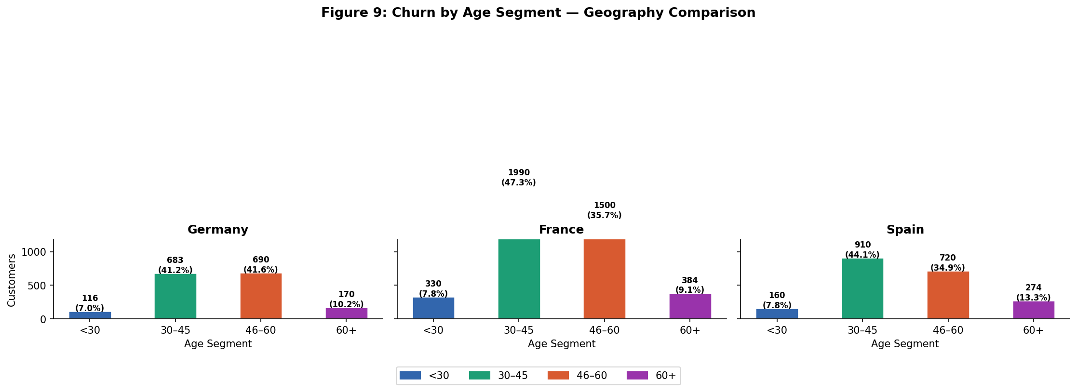
Figure 9: Churn Distribution by Age Segment Across Geographies — Germany, France, Spain

Germany’s elevated churn is concentrated in the 30–45 and 46–60 age bands, confirming that mid-life, financially active customers are the primary switching cohort in the German market. France and Spain show similar age-band patterns but at lower overall rates, suggesting that the German churn premium is a market-structural phenomenon rather than purely a demographic artefact.

4.9 High-Value Customer (HVC) Churn Analysis
The HVC analysis employs the Customer Value Score (CVS) to classify customers into Low, Medium, High, and Premium tiers.

Value Tier | Total | Churned | Churn Rate | Revenue Risk
Low | 479 | 151 | 31.5% | Low
Medium | 5,755 | 1,067 | 18.5% | Moderate
High | 3,590 | 723 | 20.1% | High
Premium | 175 | 95 | 54.3% | Critical

Table 8: Customer Value Tier Churn Analysis

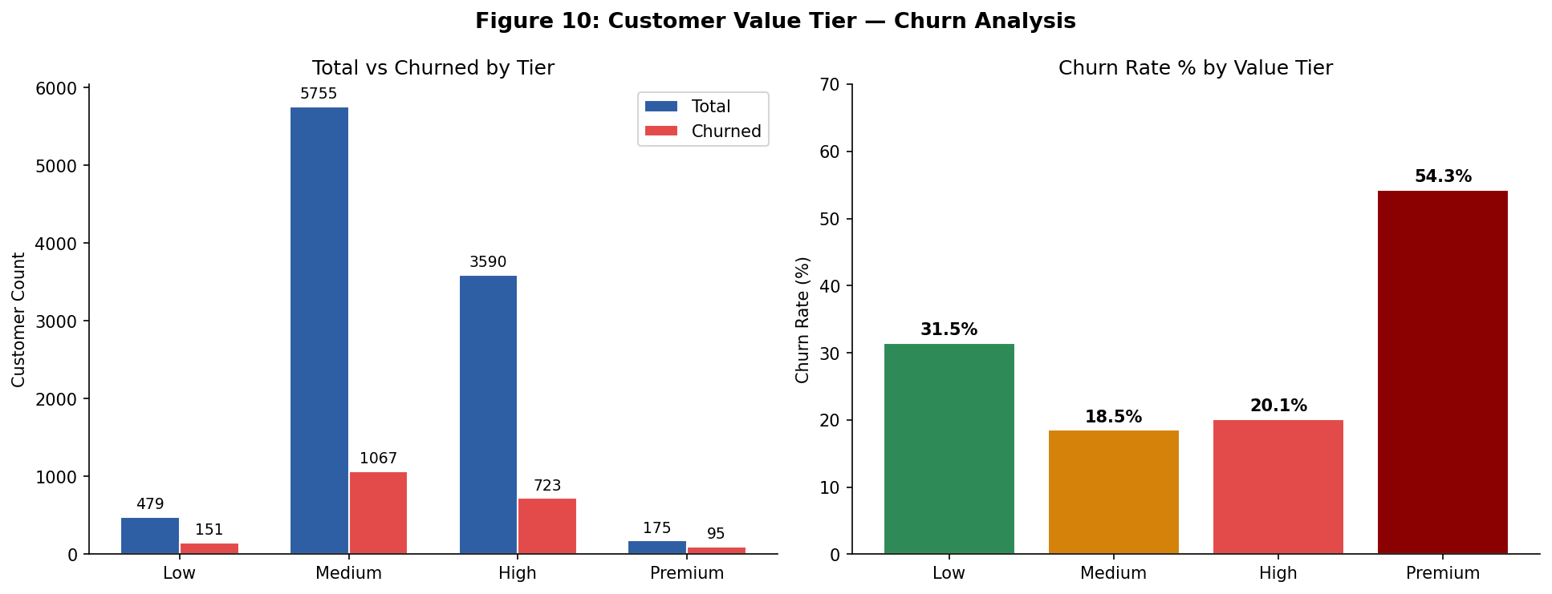
Figure 10: HVC Tier Analysis — Premium segment at 54.3% churn rate (Critical revenue risk)

The Premium segment’s 54.3% churn rate is the most alarming finding of this study. Despite comprising only 1.75% of the customer base, Premium customers churning at over half the segment rate represents a catastrophic concentration of revenue risk. These are customers with high balances, multi-product relationships, active engagement, strong credit profiles, and long tenure — and yet they churn at the highest rate of any tier.

This counterintuitive result reflects a pattern common in private banking: premium customers, precisely because they are sophisticated financial consumers, are most aware of competitive alternatives and most capable of acting on them. A bank that fails to deliver personalised, high-touch service to this segment loses its highest-value relationships to competitors who do

5. Key Performance Indicators Summary

KPI | Value | Interpretation
Overall Churn Rate | 20.4% | Above European industry benchmark (10–15%)
Highest Geographic Churn | Germany: 32.4% | 2× higher than France/Spain
Age Segment Churn Leader | 30–45 yrs: 65.9% | Core demographic — highest priority segment
Gender Churn Gap | ~8.6 pp (F vs M) | Females churn disproportionately higher
Tenure Paradox | Long-term: 61.4% of churn | Loyalty ≠ retention without active engagement
Credit Score Churn Leader | Medium band: 50.5% | Largest volume; Low band has highest rate
Balance Churn Split | Zero: 39.1% | Mid: 36.9% | High: 24% | Zero-balance disengagement leads by volume
Premium Segment Churn Rate | 54.3% | Critical — highest revenue risk concentration

Table 9: Key Performance Indicators — Consolidated Summary

6. Strategic Recommendations

6.1 Germany-Specific Retention Programme
Germany’s 32.4% churn rate — double France and Spain — warrants a dedicated country-specific programme:
- Deploy personalised relationship manager outreach to high-balance German customers.
- Conduct competitive positioning analysis specific to the German market to identify service gaps versus local and digital-native competitors.
- Introduce German-market-specific product bundles with enhanced switching costs.
- Commission qualitative exit interview research to identify primary churn triggers.

6.2 Female Customer Retention Strategy
The ~8.6 percentage point gender churn gap demands a dedicated female-customer initiative:
- Audit current product and communication design for gender-inclusive financial service alignment.
- Develop female-targeted financial wellness and investment advisory programmes.
- Introduce outcome-based loyalty recognition programmes aligned with female financial goals.

6.3 Premium & High-Value Customer Protection
The 54.3% Premium-tier churn rate is the highest-priority strategic challenge:
- Assign dedicated private banking relationship managers to all Premium-tier customers.
- Implement a ‘Red Alert’ churn trigger system for any Premium customer exhibiting product reduction, balance decline, or engagement drop.
- Design exclusive VIP service SLAs and proactive annual financial health reviews.
- Introduce contractual loyalty incentives creating structured switching costs.

6.4 Tenure Paradox Intervention
Long-term customers (>7 years) account for 61.4% of churn:
- Establish a ‘Loyalty Milestone’ programme activating special benefits at 5-year and 10-year tenure marks.
- Proactively re-onboard long-tenure customers with modern product offerings and digital platform engagement.
- Identify ‘silent churners’ — long-tenure customers with declining activity — and trigger campaigns before formal exit.

6.5 Age-Targeted Retention Campaigns
The 30–45 age band (65.9% of churn) should receive primary retention marketing investment:
- Deploy lifecycle-stage marketing addressing key 30–45 financial events: property purchase, family formation, wealth product initiation.
- Develop a competitive product suite directly countering fintech and challenger bank offerings.
- Introduce gamified financial wellbeing tools and mobile-first engagement for under-30 customers.

6.6 Zero-Balance Re-Engagement
Zero-balance customers (39.1% of churn) require proactive re-activation:
- Design a ‘Re-Activation Campaign’ targeting zero-balance accounts with personalised incentives before formal exit.
- Establish automated triggers for any account balance-to-zero event to activate a 30-day re-engagement sequence.

7. Limitations & Future Research

7.1 Study Limitations
- EDA scope only; predictive modelling (XGBoost, logistic regression, neural networks) would quantify churn probability at the individual customer level.
- Dataset lacks temporal dimensions (transaction history, frequency); longitudinal data would enrich churn causality analysis.
- Geographic segmentation limited to country level; sub-national regional analysis may reveal additional heterogeneity.
- Estimated salary variable introduces potential measurement error.

7.2 Future Research Directions
- Predictive churn modelling using ensemble methods trained on this segmented dataset.
- Customer Lifetime Value (CLV) modelling to quantify the financial cost of churn by segment.
- A/B testing of retention interventions designed from findings in this study.
- NLP analysis of customer service transcripts to identify qualitative churn precursors.

8. Conclusion
This study presents a comprehensive, segmentation-driven exploratory analysis of customer churn in European retail banking, based on a dataset of 10,000 customers across France, Germany, and Spain. The overall churn rate of 20.4% is above European industry benchmarks, with significant variation across geographic, demographic, and financial profile dimensions.

Germany emerges as the highest-risk geography at 32.4%. Female customers churn at a rate nearly 9 percentage points higher than males. The 30–45 age cohort contributes 65.9% of total churn. Long-term customers paradoxically account for 61.4% of churned volume. Most critically, Premium-tier customers exhibit a 54.3% churn rate — the greatest concentration of strategic revenue risk in the entire analysis.

The Financial Stability Score and HVC composite scoring frameworks developed in this study offer a replicable, bank-agnostic methodology for customer value and churn risk stratification. The path forward requires moving from reactive churn tracking to predictive, segment-specific engagement — treating every customer cohort as a distinct strategic challenge, and every churn event as an intelligence signal for institutional improvement.

References
Kotler, P., & Keller, K. L. (2016). Marketing Management (15th ed.). Pearson Education.
Malhotra, R., & Malhotra, D. K. (2002). Differentiating between good credits and bad credits using neuro-fuzzy systems. European Journal of Operational Research, 136(1), 190–211.
Reichheld, F. F., & Sasser, W. E. (1990). Zero defections: Quality comes to services. Harvard Business Review, 68(5), 105–111.
Van den Poel, D., & Lariviere, B. (2004). Customer attrition analysis for financial services using proportional hazard models. European Journal of Operational Research, 157(1), 196–217.
European Banking Authority (EBA). (2023). Risk Assessment Report: Retail Banking Sector, Q3 2023. EBA Publications.
McKinsey & Company. (2022). The value of getting personalization right — or wrong — is multiplying. McKinsey Insights.

